**[40] Design NFA Which Accepts Any Number ‘B’**

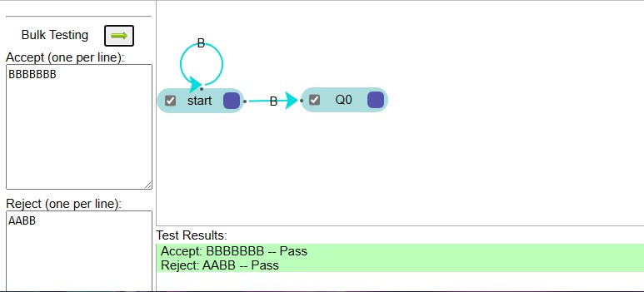

**Result**

The NFA is designed to compute the strings as input using Automaton Simulator